Packet Tracer – Configuring Wireless LAN Access

1. Topology

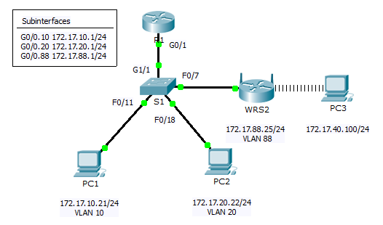

1. Addressing Table

|  |  |  |  |  |
| --- | --- | --- | --- | --- |
| Device | Interface | IP Address | Subnet Mask | Default Gateway |
| R1 | G0/0.10 | 172.17.10.1 | 255.255.255.0 | N/A |
| G0/0.20 | 172.17.20.1 | 255.255.255.0 | N/A |
| G0/0.88 | 172.17.88.1 | 255.255.255.0 | N/A |
| PC1 | NIC | 172.17.10.21 | 255.255.255.0 | 172.17.10.1 |
| PC2 | NIC | 172.17.20.22 | 255.255.255.0 | 172.17.20.1 |
| PC3 | NIC | DHCP Assigned | DHCP Assigned | DHCP Assigned |
| WRS2 | NIC | 172.17.88.25 | 255.255.255.0 | 172.17.88.1 |

1. Objectives

Part 1: Configure a Wireless Router

Part 2: Configure a Wireless Client

Part 3: Verify Connectivity

1. Scenario

In this activity, you will configure a Linksys wireless router, allowing for remote access from PCs as well as wireless connectivity with WPA2 security. You will manually configure PC wireless connectivity by entering the Linksys router SSID and password.

1. Configure a Wireless Router
   1. Connect the Internet interface of WRS2 to S1.

Connect the **WRS2** Internet interface to the **S1** F0/7 interface.

* 1. Configure the Internet connection type.
     1. Click **WRS2** **>** **GUI** tab.
     2. Set the **Internet Connection type** to **Static IP**.
     3. Configure the IP addressing according to the Addressing Table.
  2. Configure the network setup.
     1. Scroll down to **Network Setup**. For the **Router IP** option, set the IP address to **172.17.40.1** and the subnet mask to **255.255.255.0**.
     2. Enable the DHCP server.
     3. Scroll to the bottom of the page and click **Save Settings**.
  3. Configure wireless access and security.
     1. At the top of the window, click **Wireless**. Set the **Network Mode** to **Wireless-N Only** and change the SSID to **WRS_LAN**.
     2. Disable **SSID Broadcast** and click **Save Settings**.
     3. Click the **Wireless Security** option.
     4. Change the **Security Mode** from **Disabled** to **WPA2 Personal**.
     5. Configure **cisco123** as the passphrase.
     6. Scroll to the bottom of the page and click **Save Settings**.

1. Configure a Wireless Client
   1. Configure PC3 for wireless connectivity.

Because SSID broadcast is disabled, you must manually configure **PC3** with the correct SSID and passphrase to establish a connection with the router.

* + 1. Click **PC3** > **Desktop** > **PC Wireless**.
    2. Click the **Profiles** tab.
    3. Click **New**.
    4. Name the new profile **Wireless Access**.
    5. On the next screen, click **Advanced Setup**. Then manually enter the SSID of **WRS_LAN** on **Wireless Network Name**. Click **Next**.
    6. Choose **Obtain network settings automatically (DHCP)** as the network settings, and then click **Next**.
    7. On **Wireless Security**, choose **WPA2-Personal** as the method of encryption and click **Next**.
    8. Enter the passphrase **cisco123** and click **Next**.
    9. Click **Save** and then click **Connect to Network**.
  1. Verify PC3 wireless connectivity and IP addressing configuration.

The **Signal Strength** and **Link Quality** indicators should show that you have a strong signal.

Click **More Information** to see details of the connection including IP addressing information.

Close the **PC Wireless** configuration window.

1. Verify Connectivity

All the PCs should have connectivity with one another.